IDR305: Introduction to Economics for Sport Management
Final Exam: Solutions

Question 1 (15 points)
Answer:
Resource | Production of X | Production of Y | Cost of X (in Y) | Cost of Y (in X) | World price (1X=) | Specializes in (trade)
Machines | 5 | 2 | 0.4Y | 2.5X | 1.5Y | X
Workers | 2 | 4 | 2Y | 0.5X | 1.5Y | Y
Machines are relatively cheaper at producing X (lower opportunity cost), so they specialize in X; workers are relatively cheaper at producing Y, so they specialize in Y (see table above).
Max X (all resources to X) = 200×5 + 400×2 = 1000 + 800 = 1800X.
Max Y (all resources to Y) = 200×2 + 400×4 = 400 + 1600 = 2000Y.
Kink point: use machines fully for X (cheapest X-producer) = 1000X, remaining Y from workers alone = 1600Y → kink at (1000, 1600).
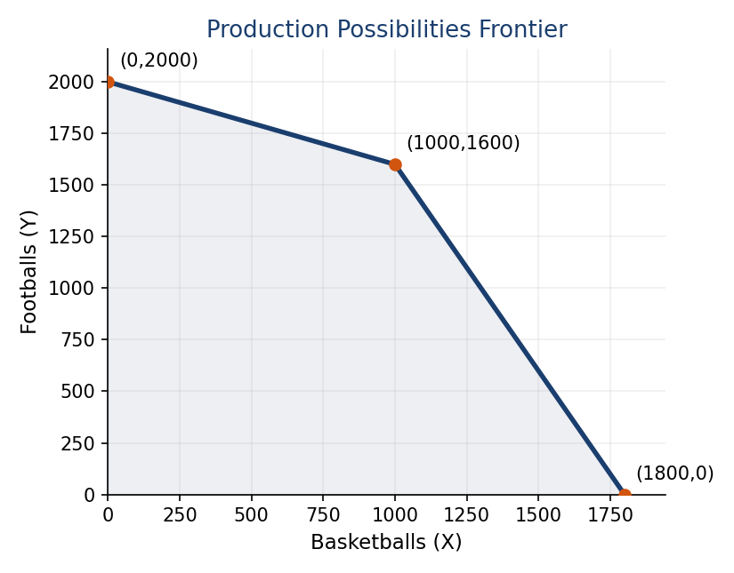
a. PPF runs (0,2000) → (1000,1600) → (1800,0), as shown above. (5 points)
b. On the lower segment (kink to (1800,0)): Y = 1600 − 2(X−1000). Setting Y=1200: 1200 = 1600 − 2(X−1000) → X−1000 = 200 → X = 1200. (3 points)
c. World price: 1X = 1.5Y. Machines’ cost of X (0.4Y) < world price (1.5Y) → machines specialize in X. Workers’ cost of X (2Y) > world price (1.5Y) → workers should NOT produce X; their cost of Y (0.5X) is below the world price of Y (1/1.5 ≈ 0.67X) → workers specialize in Y. The country produces exactly at the kink: 1000X and 1600Y. (4 points)
d. The country needs to consume 1200X but only produces 1000X → it must import 200X, costing 200×1.5 = 300Y. It keeps 1600 − 300 = 1300Y. Consumption = (1200X, 1300Y). (3 points)

Question 2 (15 points)
Answer:
a. Equilibrium: QD=QS → 20−2p = 3p → 20 = 5p → p = 4, Q = 12. (4 points)
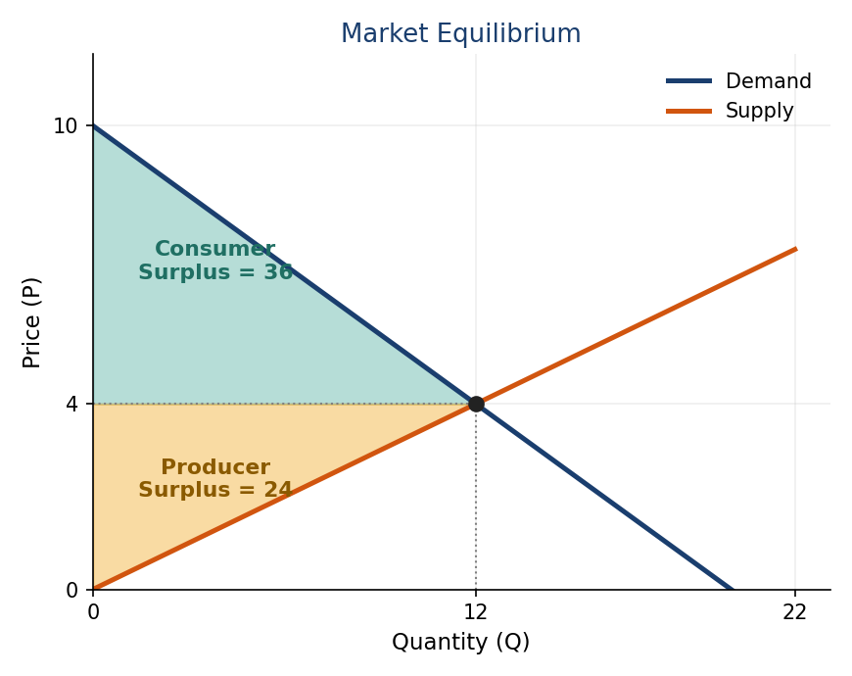
b. See graph above: demand hits the price axis at P=10 (Q=0) and the quantity axis at Q=20 (P=0); supply passes through the origin; both cross at the equilibrium point (12, 4). (6 points)
c. Producer surplus = ½ × 4 × 12 = 24. (2 points)
d. Consumer surplus = ½ × (10−4) × 12 = ½ × 6 × 12 = 36. (2 points)
e. Total social welfare = 24 + 36 = 60. (1 point)

Question 3 (15 points)
Answer:
TP (Q) | L | MP | FC | VC | TC | MC | ATC | AVC
0 | 0 |  | 40 | 0 | 40
1 | 4 | 0.25 | 40 | 40 | 80 | 40 | 80 | 40
2 | 7 | 0.33 | 40 | 70 | 110 | 30 | 55 | 35
3 | 11 | 0.25 | 40 | 110 | 150 | 40 | 50 | 36.67
4 | 16 | 0.2 | 40 | 160 | 200 | 50 | 50 | 40
5 | 23 | 0.14 | 40 | 230 | 270 | 70 | 54 | 46

a. VC = 10×L; TC = VC+FC; MC = ΔVC/ΔQ; ATC = TC/Q; AVC = VC/Q (table above). (7 points)
b. Minimal short-term price = min AVC = 35 (at Q=2). (2 points)
c. Minimal long-term price = min ATC = 50 (at Q=3 or Q=4). (2 points)
d. Produce where MC = P = 70. MC = 70 at Q=5 → the firm produces 5 units. (2 points)
e. Short-run profit = P×Q − VC = 70×5 − 230 = 350 − 230 = 120. (1 point)
f. Long-run profit = P×Q − TC = 350 − 270 = 80. (1 point)

Question 4 (10 points)
Answer:
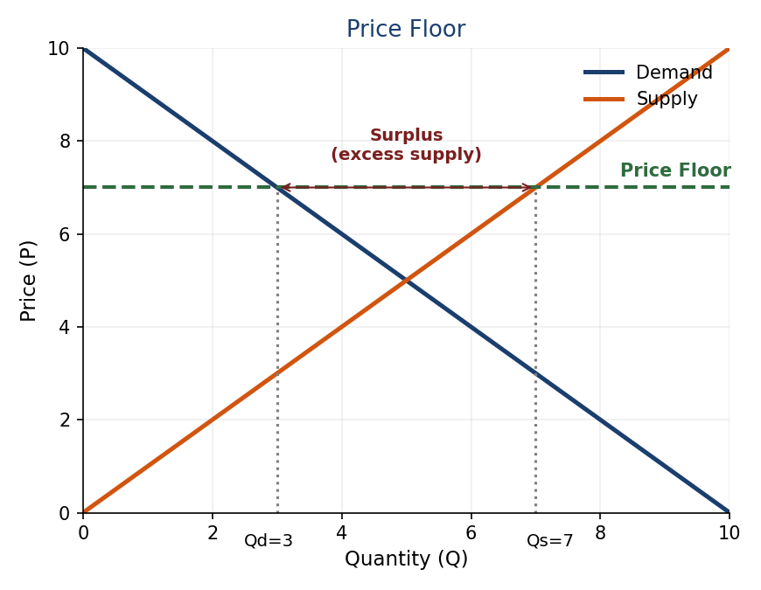
a. A price floor set above equilibrium creates a surplus (excess supply): quantity supplied exceeds quantity demanded, since suppliers want to sell more at the higher price than buyers want to buy. (5 points)
b. Example: a minimum salary / salary floor in a league (e.g. the NBA’s minimum player salary) guarantees players are paid at least a set amount, regardless of what the market would otherwise clear at. (3 points)
c. Similar: both set a legal minimum price that cannot be undercut, and both create a surplus on the relevant side of the market (more labor supplied than demanded) if binding. Different: a sport salary floor usually targets a specific labor submarket (a league) with centrally negotiated rules, while a general minimum wage applies economy-wide by law; a league floor is also typically paired with a salary CAP (ceiling) at the other end, which ordinary labor markets rarely have. (2 points)

Question 5 (10 points)
Answer:
L | TP A | MP A | VMP A (×3) | TP B | MP B | VMP B (×2)
1 | 6 | 6 | 18 | 5 | 5 | 10
2 | 11 | 5 | 15 | 9 | 4 | 8
3 | 15 | 4 | 12 | 12 | 3 | 6
4 | 18 | 3 | 9 | 14 | 2 | 4
5 | 20 | 2 | 6 | 15 | 1 | 2
6 | 21 | 1 | 3 | 15 | 0 | 0

Ranking all VMPs in descending order: 18(A1), 15(A2), 12(A3), 10(B1), 9(A4), 8(B2), 6(A5), 6(B3), 4(B4), 3(A6), 2(B5), 0(A6/B6). Taking the top 9: 18,15,12,10,9,8,6,6,4: this uses Field A workers 1–5 and Field B workers 1–4.
a. 5 workers in Field A, 4 workers in Field B. (6 points)
b. The marginal (9th) worker’s VMP = 4, so the market wage = 4. (4 points)

Question 6 (10 points)
Answer:
FV(Option 1) = 1000×1.06×1.06×1.08×1.09 = 1000×1.32270 = 1322.70 NOK.
FV(Option 2) = 500×(1.06×1.06×1.08×1.09) + 500×(1.08×1.09) = 500×1.32270 + 500×1.17720 = 661.35 + 588.60 = 1249.95 NOK.
FV(Option 3) = 1000×(1.08×1.09) = 1000×1.17720 = 1177.20 NOK.
Option 1 yields the highest Future Value (1322.70 NOK), because investing the full sum as early as possible lets it compound over the greatest number of years. Money invested earlier is always worth more at a fixed future date, all else equal. (10 points)

Question 7 (10 points)
Answer:
a. The number of ways to choose 4 balls out of 14, unordered, without replacement: C(14,4) = (14×13×12×11)/(4×3×2×1) = 24024/24 = 1001. One specific combination (11-12-13-14) is deliberately left unassigned to any team, to round the usable pool down to a clean 1,000; if that exact combination is drawn live, the draw is simply redone. (4 points)
b. Probability = 70/1000 = 7%. (1 point)
c. The Salary Cap ($112.4M in the example used in class) and the Tax Level ($136.6M) define three zones: (1) below the cap: full flexibility to sign free agents with cap space; (2) between the cap and the tax level: the team is “over the cap” but faces no financial penalty, only fewer tools to sign players (e.g. only the mid-level exception); (3) above the tax level: the team pays the luxury tax, a real, escalating dollar penalty on every dollar spent, which is then redistributed to teams below the tax line. (5 points)

Question 8 (8 points)
Answer:
a. The Squad Cost Ratio caps a club’s combined spending on player/coach wages, transfer amortization, and agent fees, as a percentage of the club’s revenue (phased in: 90% → 80% → 70%, permanent from 2025/26). (3 points)
b. 240/300 = 0.80 = 80%, which is above the 70% permanent threshold → the club is NOT compliant. (3 points)
c. Because the ratio is tied to each club’s OWN revenue, clubs that already earn the most can spend far more in absolute terms and still comply, while smaller, ambitious clubs are constrained exactly when they would need to spend to break into the elite. Critics (e.g. Peeters & Szymanski) argue this entrenches the existing hierarchy rather than promoting competitive balance. (2 points)

Question 9 (7 points)
Answer:
a. Monopsony power exists when there is effectively a single (or dominant) buyer of a type of labor. Before Bosman (1995), a football club retained rights over a player even after his contract expired, he could not simply leave for free, giving clubs buyer-side market power over players’ labor. (4 points)
b. Wages would be expected to RISE. Removing the clubs’ monopsony power means players can now sell their labor on a more competitive market (several clubs able to bid for a free agent), pushing wages up toward the competitive level that monopsony power had previously held them below. (3 points)

